**2013 -12- No. 207**

Health Warning 6

Front Back

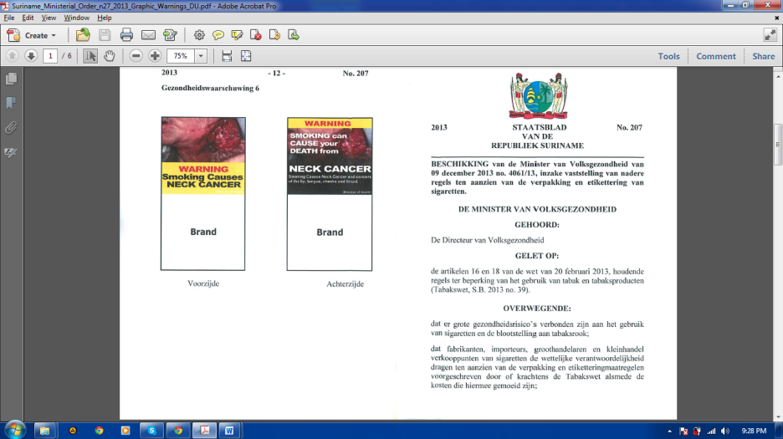



**2013 OFFICIAL PUBLICATION No. 207**

**FROM THE**

**REPUBLIC OF SURINAM**

**DECISION of the Minister of Health of December 9, 2013 No. 4061-113, on detailed rules on the packaging and labeling of cigarettes.**

**THE MINISTER OF HEALTH**

**HEARD:**

The Director of Public Health

**Having regard to:**

Articles 16 and 18 of the Law of 20 February 2013 laying down rules limiting the use of tobacco and tobacco products (Tobacco law, SB 2013 no. 39).

**CONSIDERING:**

that there are major health risks associated with cigarette use and exposure to tobacco smoke;

that manufacturers, importers, wholesalers and retailers of cigarettes carry legal responsibility prescribed by or pursuant to the Tobacco Act and the costs regarding the packaging and labeling measures;

**2013 -2- No. 207**

that the implementation of the Tobacco Act should implicate which requirements the packaging and labeling of cigarettes should meet.

**DECIDED:**

**Article 1**

To adopt the following definitions:

1. Distributor: any in this country established natural or legal person, including small shops that sell tobacco and / or tobacco products on the market on behalf of a third party;
2. Manufacturer means a person, organization or commercial entity that produces tobacco products, processes them, manufactures or sells them for the retail trade.

**Article 2**

Each packaging design cigarettes destined for the import, distribution and sale in Surinam includes the following information:

1. brand name or trademark;
2. the net weight of the package indicated in grams and the number of cigarettes in the package;
3. a health warning referred to in Article 16 of the Tobacco Act (SB 2013 no. 39) and Article 3 of this Decision;
4. name and address of the manufacturer or distributor;
5. the production date and batch number like fixed in all documents of this decision.

**2013 -11- No. 207**

Health Warning 5



Front Back

**2013 -10- No. 207**

Health Warning 4

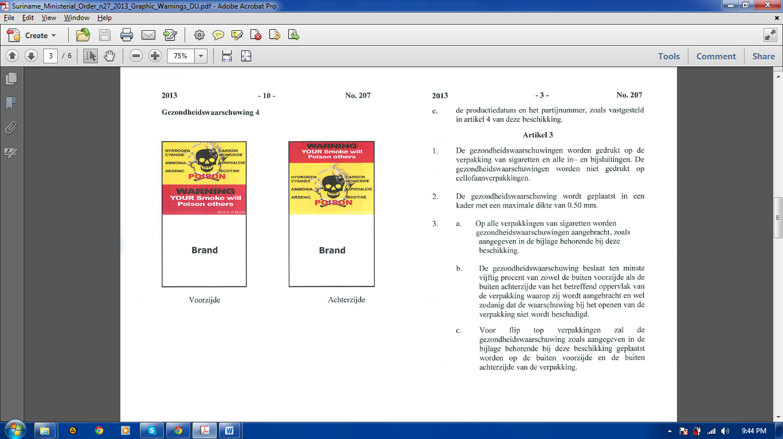

Front Back

**2013 -3- No. 207**

**Article 3**

1. The health warnings are printed on the packaging of cigarettes and all papers included in the package. The health warnings are not printed on wrappers.
2. The health warning is placed in a frame with a max. thickness of 0.50 mm.
3. a. On all packs of cigarettes commendable health warnings are affixed as shown in the appendix hereto.

b. The health warnings covers at least fifty percent of both the outside front and rear of the respective outer surface of the container in which it is applied and so that the warning is not damaged when opening the packaging.

c. With flip top packaging the health warning will be as shown in the annex to this Decision and be placed on the outside front and outside back of the package.

**2013 -4- No. 207**

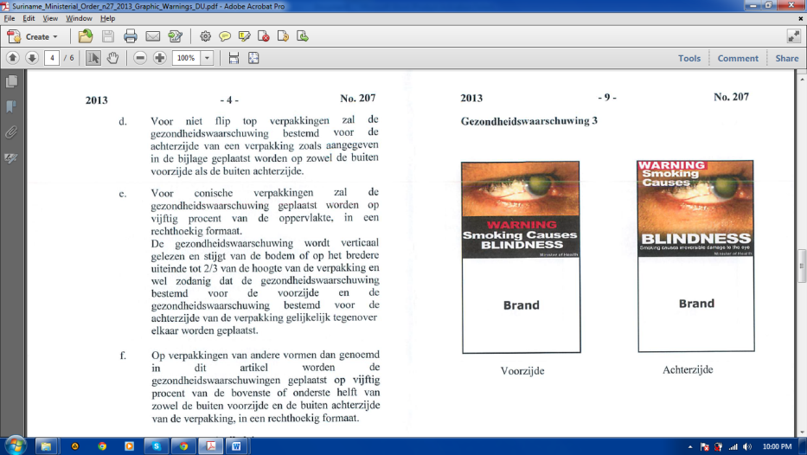d. For non flip top packaging the health warning for the rear of a packaging will be as shown in the Annex and placed on both the outside front and outer rear.

e. For conical packages the health warning will be place on at least fifty percent of the area, in a rectangular format.

The health warning will be read vertically and rises from the bottom or on the wider end to two thirds of the height of the packaging and in such a a way that health warning destined to the front and the health warning for the back of the packaging are equally placed on the opposite.

f. The packaging by other forms referred to this article, will have the health warnings placed on fifty percent of the upper or lower half of both the outside front and outside back of the package, in a rectangular format.

**Article 4**

1. a. Each packaging of cigarettes features the production date and batch number.

**2013 -9- No. 207**

Health Warning 3

Front Back

**2013 -8- No. 207**

Health Warning 2

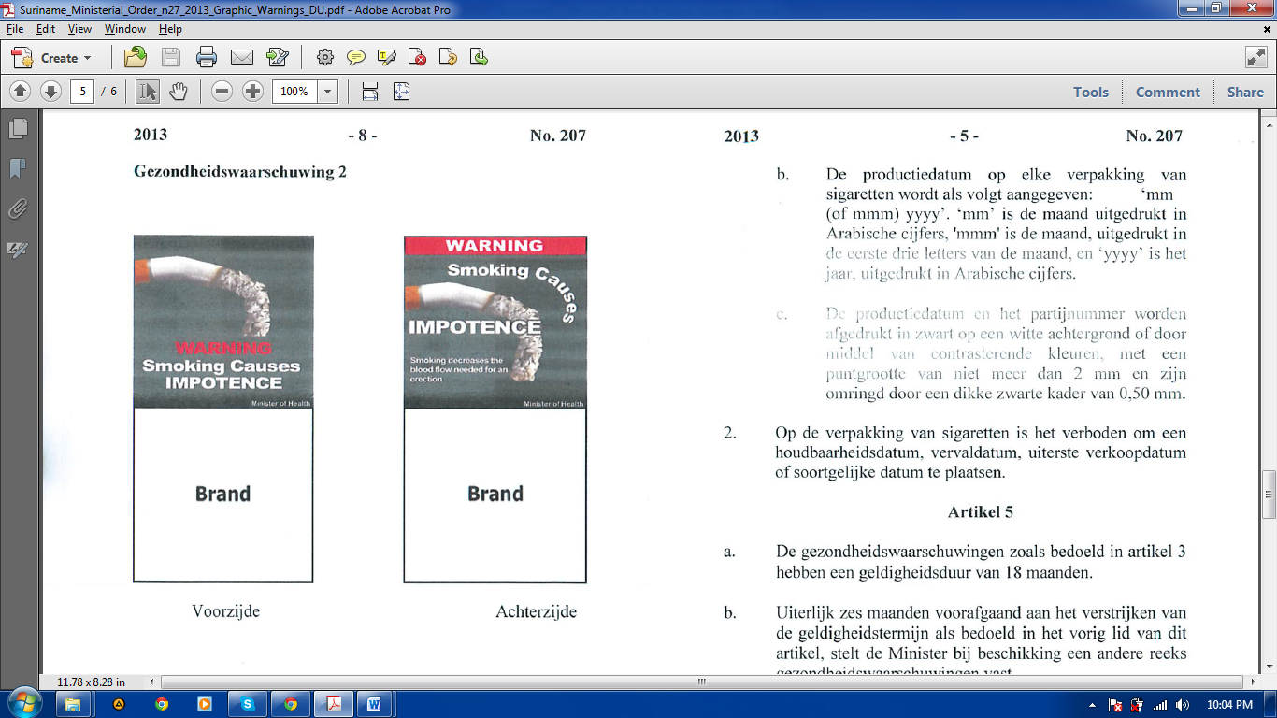

Front Back

**2013 -5- No. 207**

b. The production date on each pack of cigarettes is indicated as follows: "mm (or mmm) yyyy". "Mm" is the month expressed in Arabic numerals, 'mmm' is the month, printed by the first three letters of the month, and "yyyy" is the year, also in Arabic numerals.

c. The production date and batch number are printed in black on a white background or through contrasting colors, with a point of not more than 2 mm and surrounded by a thick black frame of 0.50 mm.

2. Packaging of cigarettes will not hold a valid till date, an expiration date, sell-by date or similar

**Article 5**

a. The health warnings referred to in Article 3 shall be valid for 18 months.

b. No later than six months prior to the expiry of the validity date referred to in the previous paragraph of this Article, the Minister shall, by order set another set of health warnings.

c. lf the provisions b of this article have not been made, the validity of the health warnings is extended for a period of 18 months.

**2013 -6- No. 207**

**Article 6**

We determine that the decision be published in the Official Gazette of the Republic of Suriname and the Advertiser of the Surinam Republic and come into force with effect from

07 June 2014.

Paramaribo, December 9 2013,

**M. BLOKLAND**

Issued in Paramaribo, on December 12 2013

The Minister of the Interior,

**S. MOESTADJA**

**2013 -7- No. 207**

**Annex to the decision of the Minister of Health on December 9, 2013 No. 4061/13 (SB 2013 No. 207), detailing rules on the packaging and branding of cigarettes.**

Flip top packaging

Health warning 1

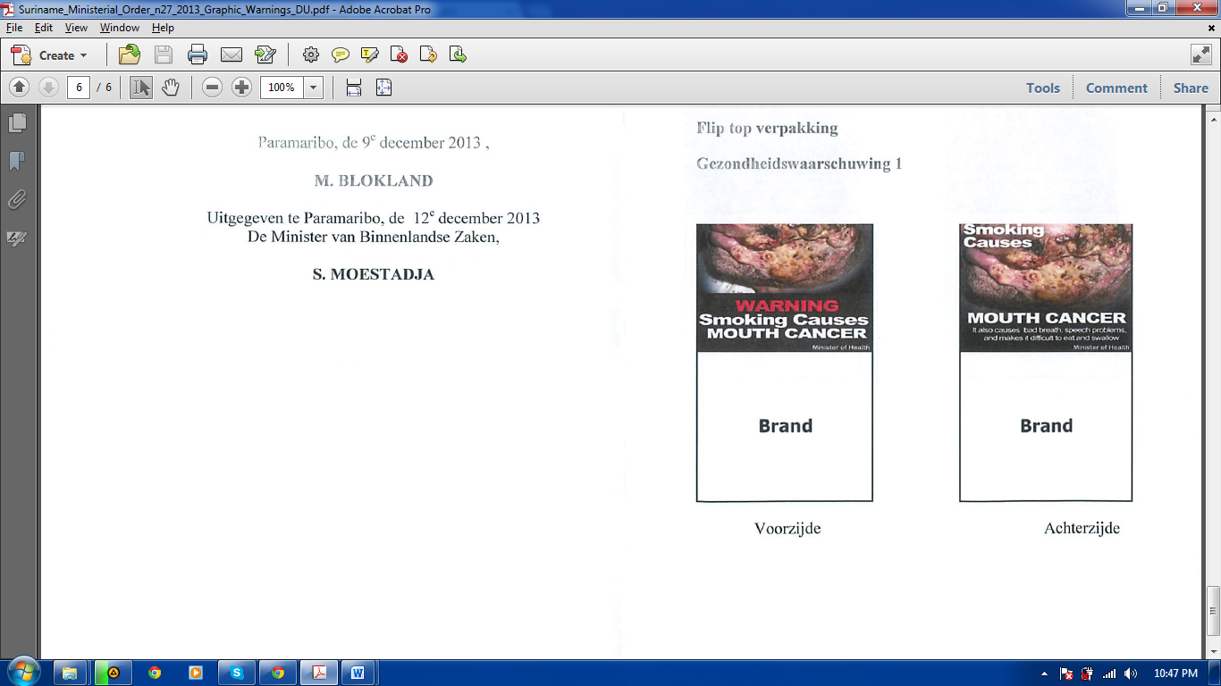

Front Back