2016 OFFICIAL GAZETTE No. 140
OF THE
REPUBLIC OF SURINAME
DECISION of the Minister of Health of November 10, 2016 no. 3553, in order to implement Article 5 sub b of the decision of the Minister of Health of 9 December 2013 no. 4061/13, regarding determination detailed rules regarding the packaging and labeling of cigarettes (S.B. 2013 no. 207).
THE MINISTER OF HEALTH
HEARD:
The Director of Public Health
IN VIEW OF:
article 5 sub b of the decision of the Minister of Health of 9 December 2013 no. 4061/13, regarding determination detailed rules regarding the packaging and labeling of cigarettes (S.B. 2013 no. 207).
CONSIDERING:
in accordance with Article 5 sub b of the aforementioned decision of the Minister of Health (S.B. 2013 no. 207), the new series of health warnings on the packaging of all cigarettes must be established, no later than six months prior to the expiry of the period, by decision of the Minister;

2016 - 2 - No. 140
that under Article 5 sub c of aforementioned decision, in the event of not re-establishing the health warnings, the period shall be extended for a period of 18 months;
that the validity period of the current health warnings shall expire on June 7, 2017;
that the Ministry deems it necessary to adapt the current health warnings on the packaging of all cigarettes;
that with this new series of health warnings, the description of the harmful effects of tobacco use on the packaging of all cigarettes has been included in the Dutch language alongside the English language.
HAS DECIDED:
Article 1
To determine:
the health warnings on the packaging of all cigarettes, as included in the appendix belonging to this decision.
Article 2
To decide that this decision will be published in the Official Gazette of the Republic of Suriname as well as in the Advertising magazine of the Republic of Suriname and shall enter into force on 7 June 2017.
Paramaribo, 10th of November, 2017,
P. PENGEL
Published in Paramaribo, the 17th of November, 2016
The Minister of the Interior,
M. M.F. NOERSALIM

2016 -3- No. 140

APPENDIX belonging to the decision of the Minister of Health of November 10, 2016 no. 3553, in order to implement Article 5 sub b of the decision of the Minister of Health of December 9, 2013 no. 4061/13, regarding determination detailed rules regarding the packaging and labeling of cigarettes (S.B. 2013 no. 207).

Health Warning 1

Brand
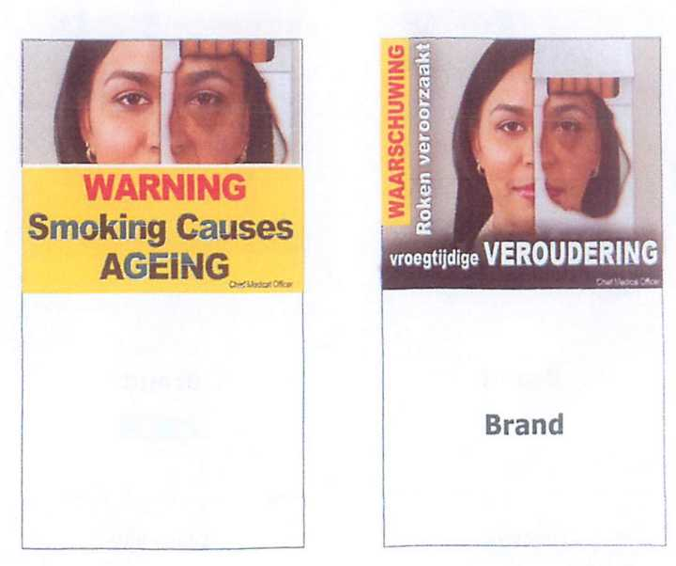

Back side
Front side

2016 -4- No. 140
Health warning 2

Brand
WAARSCHUWING
Brand
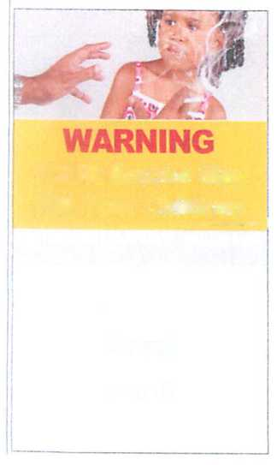

Tabaksrook Kan Dodelijk Zijn Voor Uw Kinderen

Brand

Front side

Back side

2016 - 5 - No. 140
Health warning 3

WARNING

Tobacco Causes MOUTH CANCER
Brand
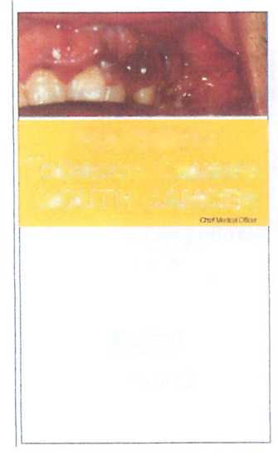
Brand
WAARSCHUWING
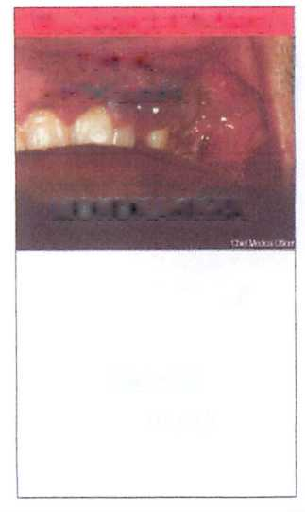
Tabak veroorzaakt

MONDKANKER

Front side

Back side

2016 - 6 - No. 140
Health warning 4

Quït
Smoking Nowl

Brand
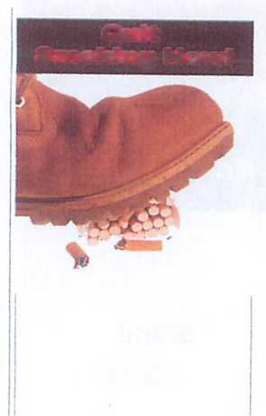
IK STOP NU MET ROKEN !

Brand

Back side

Front side

2016 - 7 - No. 140
Health warning 5

WARNING
Smoking Causes
IMPOTENCE
WAARSCHUWING
Roken Veroozaakt
IMPOTENTIE
Brand
Brand
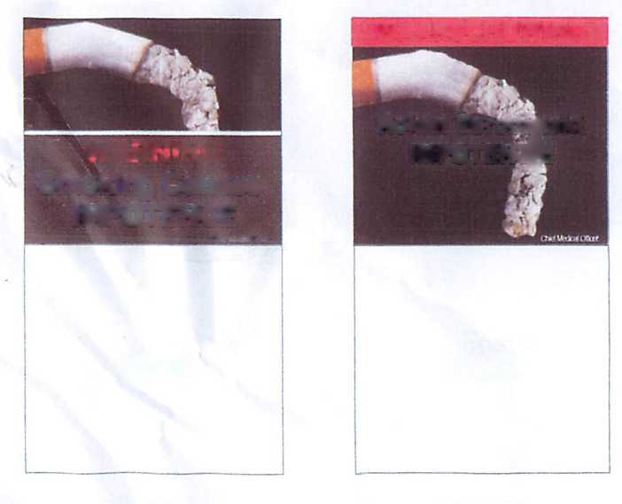
Back side

Front side

2016 - 8 - No. 140
Health warning 6
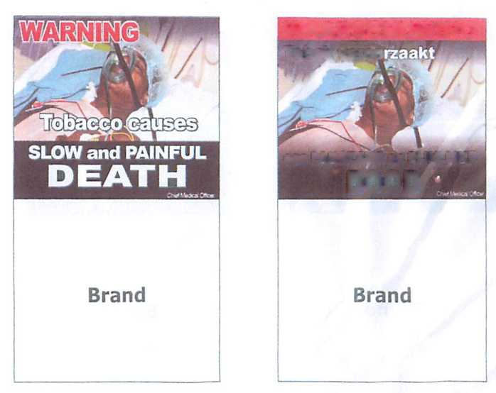
Back side

Front side

